CSA6303 - THREAT INTELLIGENCE AND NETWORK SECUR

Assessment Tool 1: CONCEPT MAPPING
Faculty : Dr.V.Parthipan SLOT A

Topics: Network Security Fundamentals | Security Goals (CIA Triad) | Types of Network Threats
|Introduction to Threat Intelligence Types of Threat Intelligence (Strategic, Tactical, perational) -Threat Intelligence Lifecycle — Applications in IT Industry

CO1: Interpret security principles, network threats, and the role of threat intelligence in cybersecurity.

Total: 50
Student Name : K Muni Kuladeep Register number: 192311096

Code of Conduct:

I K Muni Kuladeep (192311096) certify that this submission is my original work and that I have adhered to the guidelines specified for this assessment. I understand that any violation of academic integrity rules will result in disciplinary action.

K Muni Kuladeep
Signature of the student

Answer 9: Scenario-Based Concept Map of a Major Network Attack
Question: Create a scenario-based concept map for an organization experiencing a major network attack. Integrate the CIA Triad, types of network threats, Strategic, Tactical and Operational Intelligence, and the Threat Intelligence Lifecycle to show how the organization can understand, prioritize and respond to the threat.
Scenario: An e-commerce company is hit by a major attack. An employee opens a phishing email, the attacker reaches an unpatched web server, moves laterally to the database servers, steals customer records and then encrypts the systems with ransomware. A denial-of-service flood is launched at the same time to distract the security team.
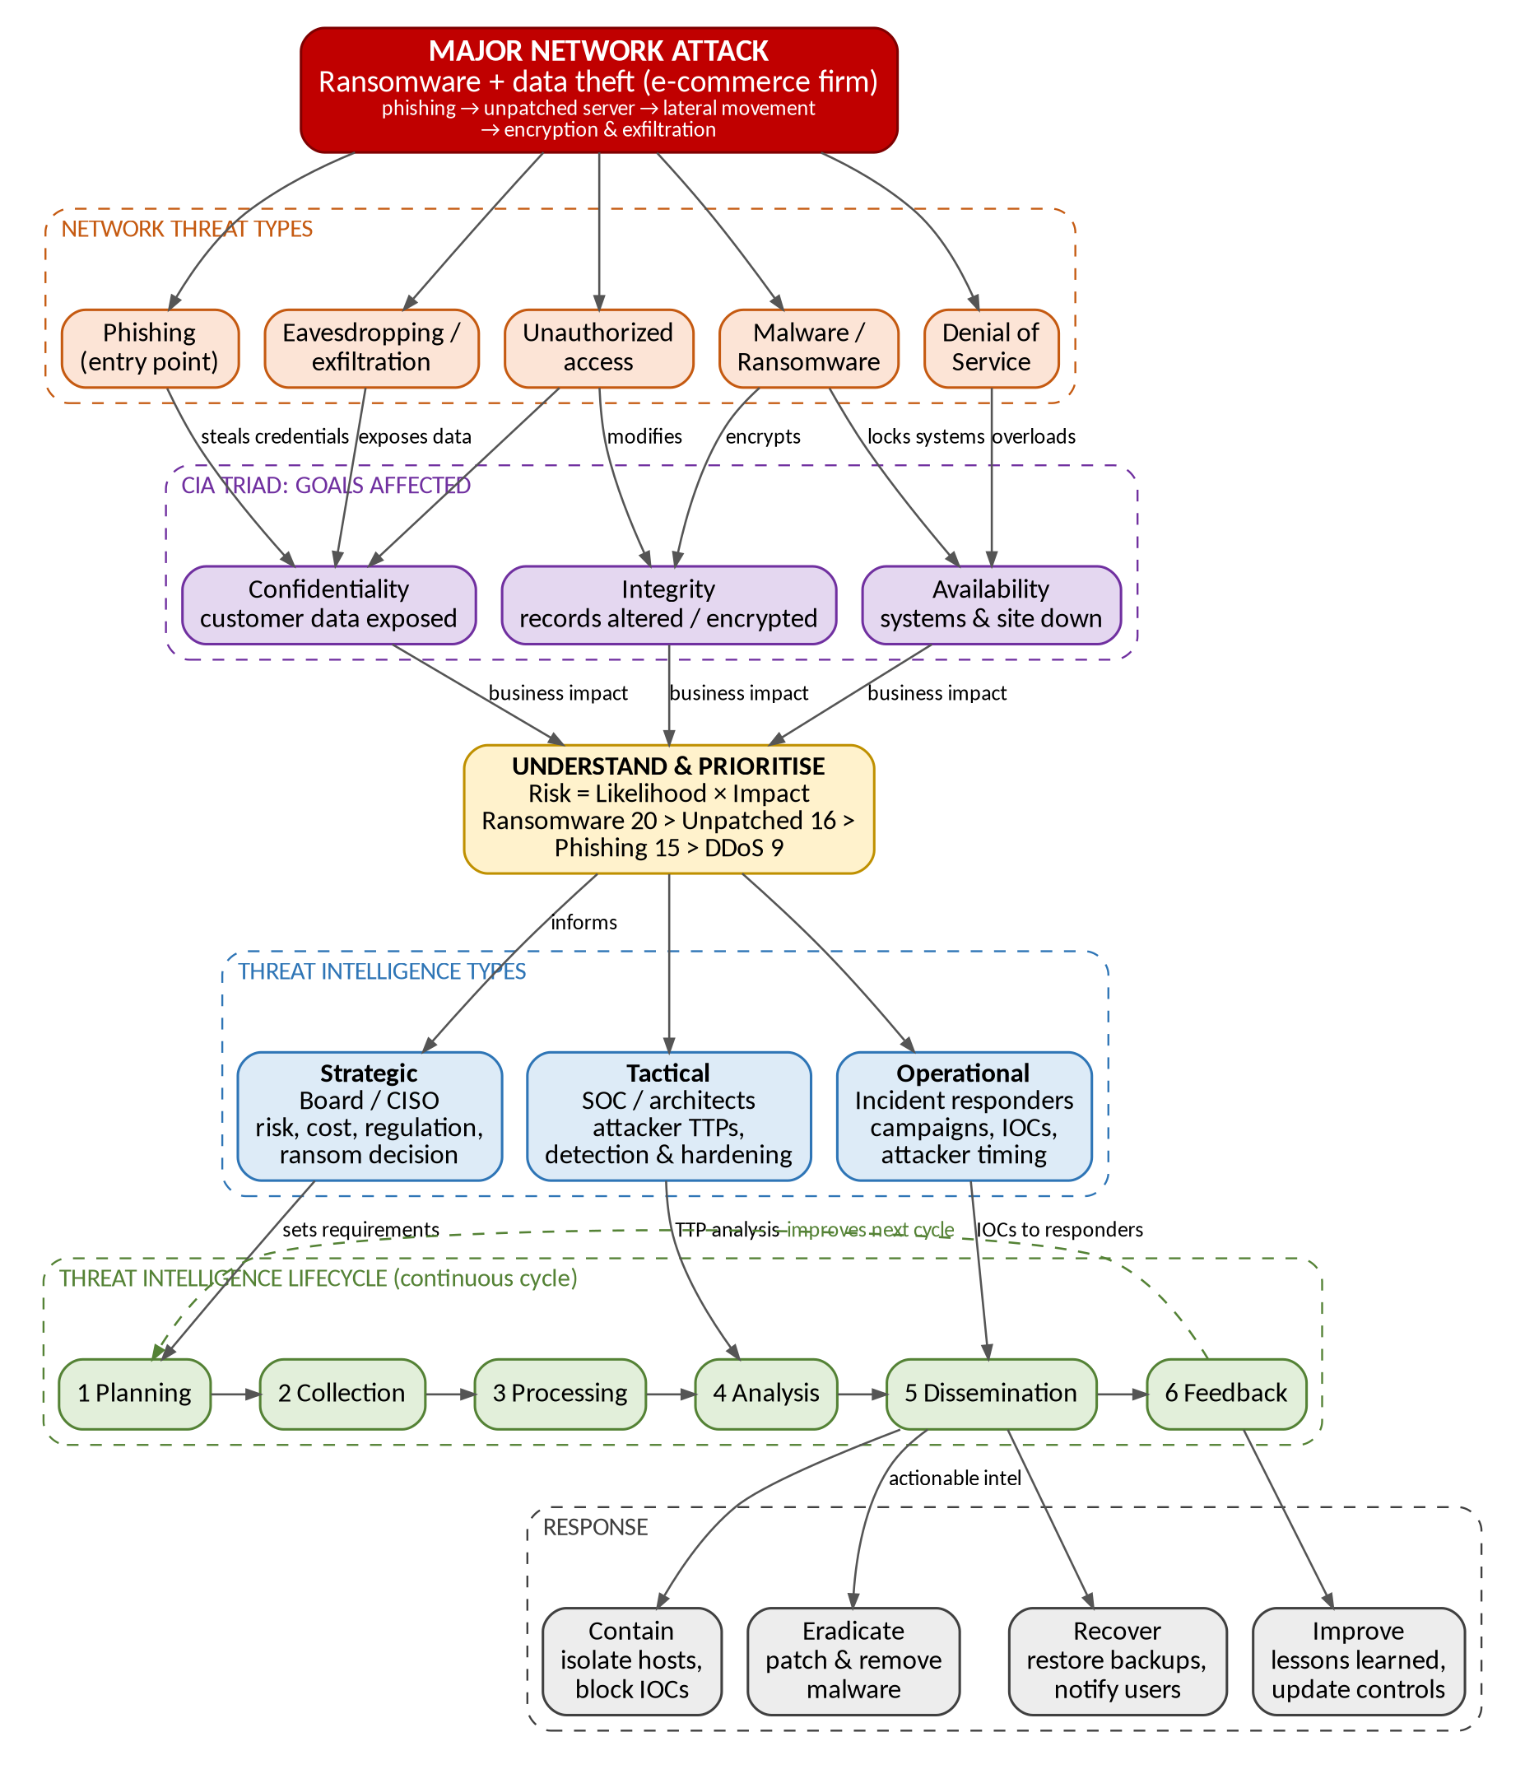
Figure 1: Scenario-based concept map for a major ransomware and data-theft attack
1. How the threats and the CIA Triad connect
The map starts from the attack, branches into the network threat types that made it up, and shows which security goal each threat damages. One threat can hit several goals at once.
Network threat | CIA goal affected | What happened in the scenario
Phishing | Confidentiality | The employee entered credentials, giving the attacker a valid login.
Unauthorized access and lateral movement | Confidentiality and Integrity | The attacker used the unpatched server to reach databases and could read and change records.
Eavesdropping / data exfiltration | Confidentiality | Customer personal and payment data was copied out of the network.
Malware / ransomware | Integrity and Availability | Files and databases were encrypted, so data was altered and unusable and the shop stopped trading.
Denial-of-service | Availability | The traffic flood kept the website and support services slow or offline and distracted defenders.

2. Understand and prioritize the threat
The organization ranks each threat with Risk Score = Likelihood × Impact (each rated 1 to 5) so that effort goes to the biggest risk first.
Threat | Likelihood | Impact | Risk score | Priority
Ransomware | 4 | 5 | 20 | 1 (Critical): isolate and restore from backups
Unpatched server exploit | 4 | 4 | 16 | 2 (High): patch and close the entry point
Phishing | 5 | 3 | 15 | 3 (High): block email, reset credentials, train users
DDoS | 3 | 3 | 9 | 4 (Medium): upstream filtering and rate limiting

3. Role of the three types of threat intelligence
Type | Main users | Question it answers | Use in this attack
Strategic | Board, CISO, risk managers | Who targets our industry and what is the business risk? | Decide on budget, regulatory reporting, customer communication and the ransom policy; shows the long-term trend of ransomware against retailers.
Tactical | SOC analysts, security architects | How do these attackers work (TTPs)? | Map the attack to MITRE ATT&CK, write detection rules for phishing and lateral movement, harden servers and email.
Operational | Incident response team | What is happening now and what comes next? | Use IOCs (malicious IPs, domains, file hashes) and attacker timing to block command-and-control traffic and hunt for infected hosts.

4. Threat Intelligence Lifecycle applied to the attack
Phase | Activity in the scenario
1. Planning and Direction | The CISO sets requirements: which group is attacking, what was taken, are we still exposed, and what must be reported.
2. Collection | Logs, EDR and firewall data, the phishing email, malware samples, OSINT, commercial threat feeds and ISAC sharing are gathered.
3. Processing | Data is normalized, de-duplicated and enriched, and IOCs are extracted and loaded into the SIEM.
4. Analysis | Analysts correlate IOCs with internal logs, rebuild the attack path, identify the group and TTPs, assess the impact on confidentiality, integrity and availability and rate confidence.
5. Dissemination | Tailored output goes to each audience: an executive brief (strategic), detection rules (tactical) and IOC blocklists (operational).
6. Feedback | Stakeholders say what was useful and what is missing, so the requirements and sources are improved for the next cycle.

5. Response path shown at the bottom of the map
- Contain: isolate infected hosts, disable compromised accounts and block the IOCs at the firewall, DNS and email gateway.
- Eradicate: remove the malware and persistence, patch the unpatched server and fix the exploited weakness.
- Recover: restore systems from clean, tested backups, verify data integrity, bring services back in priority order and notify affected customers and regulators.
- Improve: hold a lessons-learned review and feed the findings back into the lifecycle (the dashed Feedback arrow) to update controls, playbooks and training.
Conclusion: the CIA Triad shows what was damaged, the threat types show how it was damaged, risk scoring shows what to fix first, the three intelligence types give each decision maker the right information, and the lifecycle turns raw data into a repeatable response that improves after every incident.

Answer 10: Applications of Network Security and Threat Intelligence in the IT Industry
Question: Design a comprehensive concept map demonstrating the applications of Network Security and Threat Intelligence in the IT industry. Connect network security fundamentals, the CIA Triad, network threats, Threat Intelligence, Strategic/Tactical/Operational Intelligence and the Threat Intelligence Lifecycle with applications such as threat monitoring, incident response, vulnerability management, risk assessment, security operations and organizational decision-making.
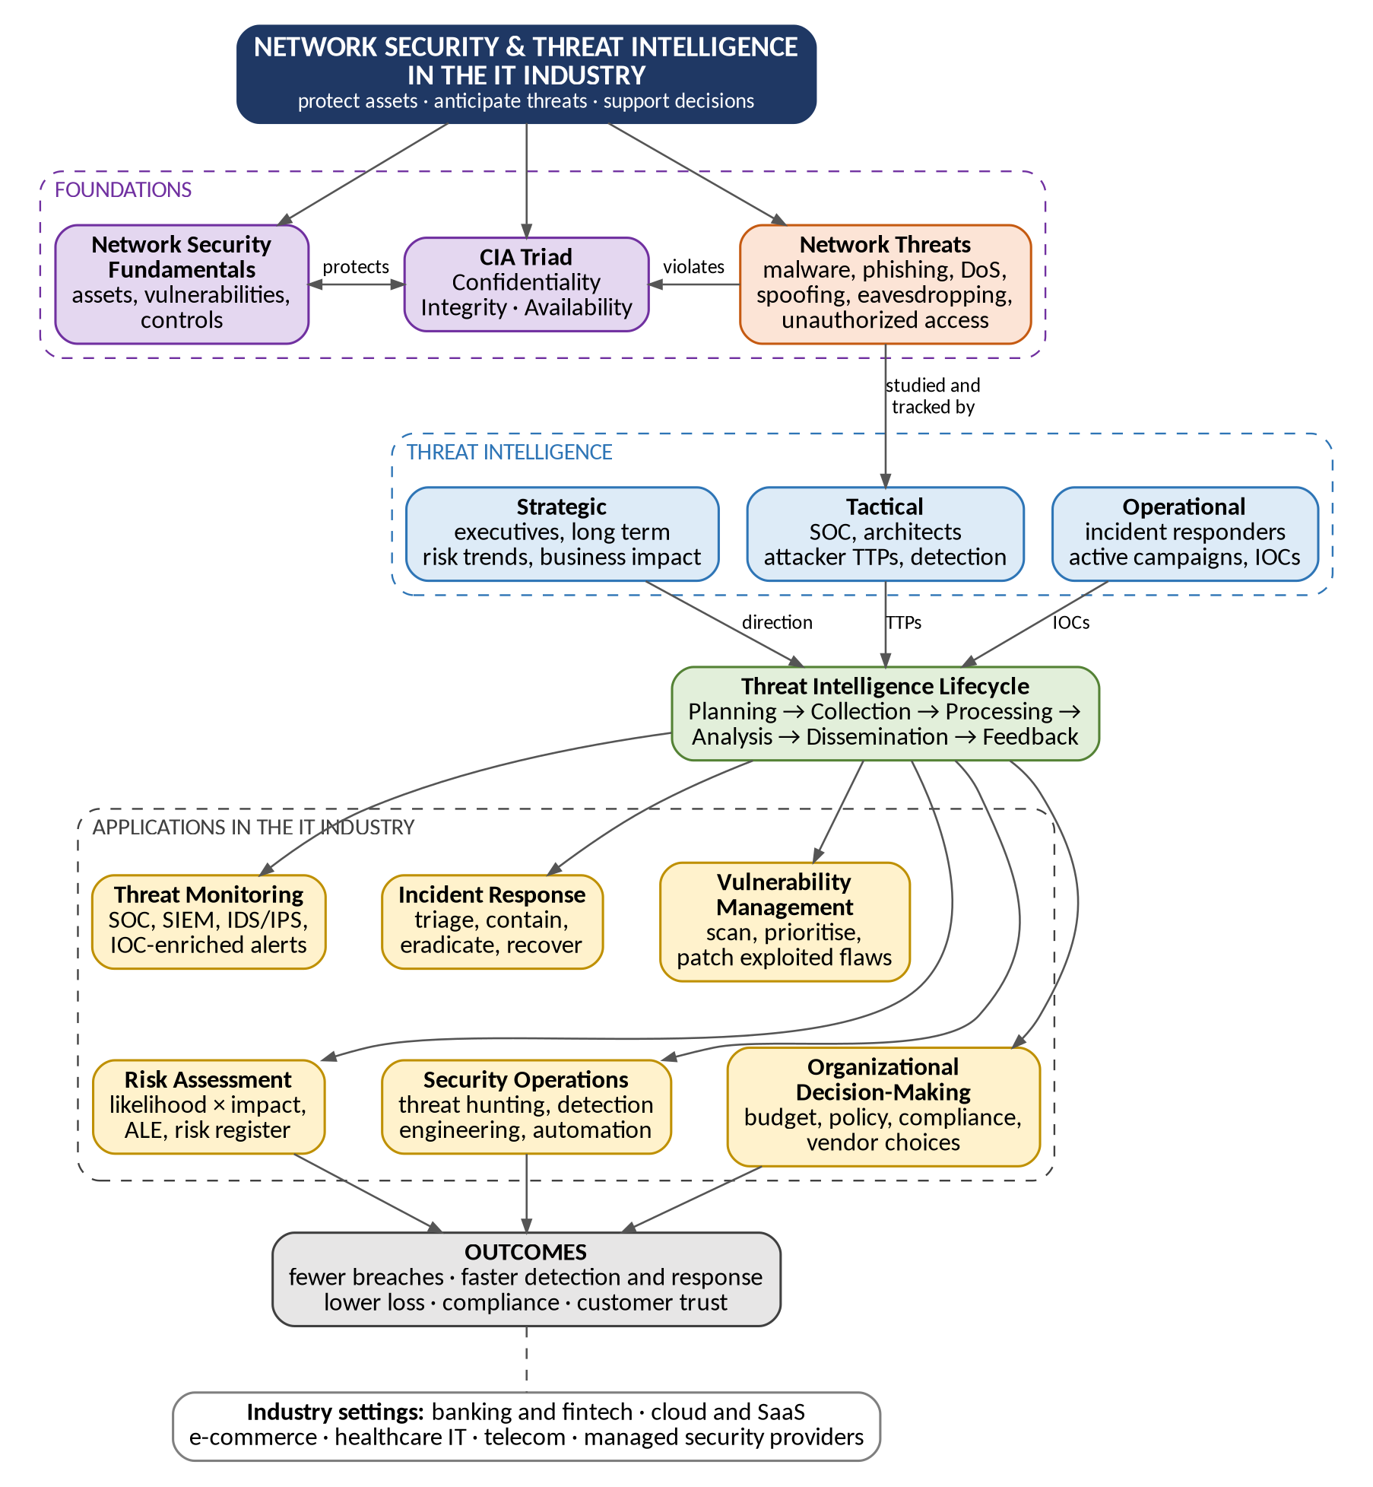
Figure 2: Concept map of network security and threat intelligence applications in the IT industry
1. Reading the map
- Foundations: network security fundamentals (assets, vulnerabilities, controls) protect the CIA Triad, while network threats violate it.
- Threat Intelligence: these threats are studied and tracked through strategic, tactical and operational intelligence, produced by the lifecycle (Planning, Collection, Processing, Analysis, Dissemination, Feedback).
- Applications: the finished intelligence feeds six IT-industry applications, which lead to the outcomes of fewer breaches, faster detection and response, lower loss, compliance and customer trust.
2. Applications in the IT industry
Application | Network security role | Threat intelligence used | Example in practice
Threat monitoring | Watches network traffic and logs for attacks on confidentiality, integrity and availability (IDS/IPS, firewalls, SIEM). | Operational: IOC feeds (malicious IPs, domains, hashes) enrich alerts. | A SOC matches a feed of ransomware domains against DNS logs and raises an alert.
Incident response | Contains and removes attacks, then restores systems and data. | Operational and tactical: attacker TTPs and IOCs guide scoping and containment. | Infected hosts are isolated and the attacker's command servers are blocked.
Vulnerability management | Finds and fixes weaknesses in servers, devices and applications. | Tactical: shows which flaws are being exploited in the wild so they are patched first. | An actively exploited server flaw is patched before low-risk findings.
Risk assessment | Measures the likelihood and impact of threats on assets (Risk = L × I, ALE). | Strategic: industry trends and actor intent update likelihood and impact. | A rise in ransomware against retailers raises the risk score in the risk register.
Security operations | Runs daily defence: hunting, detection engineering, automation (SOAR) and tuning. | Tactical and operational: ATT&CK techniques drive hunts and detection rules. | Analysts write rules for credential theft and lateral movement seen in reports.
Organizational decision-making | Aligns security with business goals, policy and compliance. | Strategic: executive reports on threats, costs and regulation. | The board approves budget for EDR and backups, or selects a cloud vendor, using threat evidence.

3. How the three intelligence types serve the applications
Type | Applications it mainly supports
Strategic | Risk assessment and organizational decision-making (long-term, business-level).
Tactical | Vulnerability management and security operations (medium-term, technical defence design).
Operational | Threat monitoring and incident response (short-term, active campaigns).

4. Examples across IT-industry sectors
- Banking and fintech: share phishing and fraud indicators through sector groups such as FS-ISAC; protect transaction integrity.
- Cloud and SaaS providers: defend against DDoS and account takeover, protect tenant data confidentiality and keep high availability.
- E-commerce: protect payment data and price integrity, and use intelligence on credential stuffing and card skimming.
- Healthcare IT: protect patient record confidentiality and keep systems available against ransomware.
- Telecom and managed security providers: monitor many customers at once and turn shared intelligence into detections for all of them.
5. Benefits and challenges
- Benefits: earlier detection, faster and cheaper incident response, better patch prioritization, evidence-based budgets and stronger compliance.
- Challenges: too many low-quality feeds, false positives, shortage of skilled analysts, and the need to keep intelligence timely and relevant.
Conclusion: network security fundamentals and the CIA Triad define what must be protected, threats show what can go wrong, and the three types of threat intelligence, produced through the lifecycle, turn that knowledge into everyday practice across monitoring, response, vulnerability management, risk assessment, security operations and business decisions.

